Augmented Reality based Hand Gesture Recognition Towards 3D Geometry
Dr A.F.M. Saifuddin Saif
American International University-Bangladesh
Faculty of Science and Information Technology, Dhaka, Bangladesh
Email: Saif@aiub.edu

Md. Mashiul Azam Chowdhury Efti, Md. Rakibul Hossain, Md. Reza Ul Karim, Rajesh Saha
American International University-Bangladesh
Faculty of Science and Information Technology, Dhaka, Bangladesh
Email: {macefti276, hossainmohammadrakibul, rezaul.bd77, rajeshsaha782}@gmail.com

Abstract— The modern development in technology-enhanced learning research outcome into augmented reality and instead of interactive tool like use of any device for gesture recognition, hand is more preferable and suitable as it is an instinct to draw gesture using hand. Hand gesture is natural to its user but as well as there are many difficulties for this gesture recognition like deforming of hands, color of hands or unusual gesture. So, researcher is trying to recognize this hand gesture with minimalist strategy and applying it to various parts of life like education especially geometry and mathematical learning is now in great consideration. Gesture recognition is already installed in some predefined application and games but in a very restricted way and the collaboration among the user is not found that much. Moreover, the deployed method is not that much connected with augmented reality. very few works let the user interact and related with geometry learning. This paper presents a summarization of gesture recognition for learning purpose with various aspects like framework, methodology, experimental results and dataset. Apparently 80 papers were selected for review based on keywords and other recommendation. Among them forty-one papers from various authenticated documentation was selected for summarization.

Index Terms—Hand gesture, Augmented reality, 3D geometry

I. Introduction
From the very beginning of educational ascension mathematics has taken a special division. Geometry is one of the most affluent area of this. But from the very early stage, geometry learning has become difficult with the traditional tools and methods. Learners from preliminary stage get phobic about geometry. Many aspects like 2D and 3D plan, trajectory remain obscure to them and this reflects in their future learning process and potential. They lack of knowledge of those particular area and as the fundamental remain weak, the next phase started to be harder to them and in future the find whole mathematics as with complexity and fear.
Augmented reality has becoming more and more popular to the generation, what actually make the researcher to think that augmented reality can be a better medium of learning. What augmented reality does is mix the real world with virtually created object and give a better way to that object so that it seems the user is engaging with real time object. Now a days many games and application based on augmented reality ids found and children are interacting with them well. A tool like device is needed to interact with the augmented object. So now the focus is to use the technology based on Hand Gesture as the hand works like the best interactive tool with real time object and gesture is natural. But the main impediment to this field is different shape, color, posture of hand. So many researchers come with many proposed ideas to recognize the hand gesture with maximum efficiency. Moreover, the research in educational discipline also trying to ensure that both the student and teacher can interact, so that the learning can be more fruitful. Distance is also a great thing to deal cause student from different distance should participate in interacting the augmented object.
This paper proposed a method called “Modified Extrusion Technique”. The paper is sectioned in previous research study, proposed research methodology, experimental results and discussion and conclusion. All the references were added to the last section of the paper.

II. Previous Research Study
The first augmented reality-based application was a head mounted display invented by Ivan Sutherland paved the way of AR. It was named The Sword of Damocles in 1968. In 1972, another invention named Video place developed by Myron kthe first augmented reality-based application was a head mounted display invented by Ivan Sutherland paved the way of AR. It was named The Sword of Damocles in 1968. In 1972, another invention named Video place developed by Myron Kugar was a milestone. It gave the user an interactive environment. In 1998 AR was used for navigation by NASA in their X-38 spacecraft. A game named AR Quake was the first AR based game. Uses of AR in smartphone started in early 20s. Many worked has done to establish augmented reality in various discipline of education like medical, engineering with limitations.
Now a days the main goal is to increase and use the spatial ability. Spatial ability presents an important aspect of human intelligence. There are five things that can be the fundamental blocks of spatial ability are perception, visualization, rotation, mental rotation and orientation. In recent studies it has been verified that spatial ability can be improved by geometry education. 3D modeling with 6DOF (Six Degree of freedom) has been taken as a massive sector of research work. In recent years there are immersive works related to pure education using Augmented Reality. It is mentionable that CyberMath [1] is an avatar-based application that helps to learn mathematics but remotely not interactively and desktop dependent. Other desktop-based application like Geometer’s Sketchpad [1], Cindarella [1], Euklid [1] and Cabri Geometry [1]. They intendent with dynamic support but only for two-dimensional geometry.
In 2013, Volkswagen utilizes increased reality as their vehicle manuals. The utilization of the MARTA application through the iPad can enable clients to see the inner functions of the vehicle so the administration mechanics comprehend what they are managing. The MARTA application can likewise indicate progressive directions to assist mechanics with the tasks they are chipping away at. It can even help with supplanting parts. It can even be as explicit as which bearing the parts ought to confront. The MARTA application can be utilized for more corrective tasks too, including perceiving how extraordinary shading paint employments can look on your vehicle. In 2014, the Google Glass is uncovered and is made accessible for shoppers. The Google Glass wasn't as fruitful as designers trusted it would be, yet it showed the capability of what wearable expanded reality could be. The second emphasis as of now is by all accounts all the more encouraging and more helpful. Rather than utilizing the Glass to look through internet-based life and different applications, assembly line laborers are utilizing the innovation to help with regular work. It helps walk the laborers through their everyday undertakings and be more beneficial and productive. In 2016, Microsoft presents the following emphasis of wearable expanded reality. The HoloLens is by all accounts everything that the Google glass needed to be, however surely not as cautious and wearable in regular daily existence and is without a doubt costlier. The innovation progression between the two is obvious, however the value scope of $3000 and $5000 are out of a great many people's financial plans.
In most recent test in 2017, An assessment of two strategies for explanation of 3D drawing motions, surface illustration and air drawing were exhibited for the spatial referencing of genuine world protests in expanded reality. Surface illustration draws specifically on genuine world surfaces, while at the client's fingertips air drawing is anticipated into the world when it is discharged. Exploratory outcomes demonstrate that surface illustration is more exact than air drawing and exquisite comments are drawn quicker than unglazed ones. Clients additionally favored surface illustration over air drawing and beautification was commonly valued. It is noticed that our discoveries reach out past HoloLens to any AR and VR gadget that distinguishes hand developments and has an ecological model.
Recently AR application for mobile and non-mobile devices are found. Our idea is to make an application based on Augmented Reality for 3d geometry by gesture recognition using hand. But it is unaware to us that specifically any application or system that directly helps tom learn geometry. Several apps found that they provide a limited benefit like fundamental view. But they are not interactive. Moreover, hand gesture recognition using Augmented Reality hardly found. Many procedures have been followed up by traditional method like deep learning or modified neural network but they are not implemented using AR for interactive 3D geometry building. As the time goes it become more and more essential to invent an interactive system based on modern technology and it can be said that Augmented reality is the best option.
Till now there are very few works hardly found worked fully with geometry and augmented reality. So, the field is yet unirrigated. Augmented reality can be chosen as a best medium of learning. A recent survey showed that the pupils who are less interactive to the class, they are found in the successor group of class when the medium turned into augmented reality instead of typical teaching method. Additionally, the good performer is assured with a high-performance teaching system which really gives a fruitful outcome. The distance between the students is narrowed down. In most of the education system followed a simple rule more or less. In any kind of teaching system, they first give the theory first than come the implementation or practical. For that the outcome remain less fruitful. In terms of augmented reality both the theory and practical work parallelly. So, the teaching become more efficient.
Before starting our research, we go through some papers to catch up with the recent research in augmented reality in education special mathematics, more specifically geometry. We selected some method to overview and then we go through the paper with some prospective of method, framework and accuracy acquired. Besides it should be mentioned that the augmented system must be low cost, good accuracy grabber, interactive and easy to use for the user especially preliminary school going children.
Table 1. Selected methods with reference number
The “extrusion” technique [5] | Neural networks [2]
Construct3D (robust dynamic 3D geometry software in Augmented Reality) [9] | Baseline CNN Architecture: CNN and Adapted CNN architecture [8]
Fingertips tracking [4] | An auto encoder model [6]
Trajectory based method [3] | HOG-LBP Featured model. [7]

According to the chosen method the extrusion technique was introduced at the year 2017. Combined method of AR, conventional 2D GUIs and ubiquitous computing elements was published in a conference. Fingertips tracking was come to light in the year in 2002 and this is the oldest paper in the list but it was chosen for its marker less feature. Trajectory based method was published in the year 2018 along with neural networks. Baseline Convolutional Neural Network Architecture: CNN and Adapted CNN architecture were introduced in the year 2018. In the year 2015 an auto encoded model was published. Combination of Histogram of Oriented Gradients (image processing) and Local Binary Pattern was published in the year 2018

The extrusion technique turns 2D shapes into 3D and contruct3D is actually a space sharing tool. A virtual space can be shared within multiple user using Comnstruct3D. next framework is subdivided into training phase where it learns to select feature using Kinect and after that the recognition phase come. Next framework includes background segmentation, noise removal and binary thresholding. Another framework made of augmented desk interface and fingertips tracking. CNN based framework includes convolution and pooling operation and classification with performance of parameter optimization.
Unnamed dataset was used in extrusion technique and the parameter used is the relationship between the geometric forms. Fingertips method used their own made dataset and it used Linux OS, Pentium iii 500 MHz, Hitachi iP5000 image processing board, Nikon laired-s270. In trajectory base method self-made dataset were used and the parameter used to perform the experiment were Acer 5750G notebook, Intel corei5-2450M, 2.5 GHZ, 4GB ram, Win & DEV C++ and C, OpenCV 2.1. Neural Network based method also used their own dataset and their parameter were Corei7(4720),2.6 GHz, 8GB ram. Baseline Convolutional Neural Network Architecture select Hand gesture dataset of LSP as their dataset and the parameter was total of 10 gestures that match the pinch, scale, buckle, hold, grab, rotate, crawl, OK, cut, shoot. Auto encoded model chooses confusion matrix of the classification as their dataset and various scale, pinch, rotation was taken as parameter. NSU hand posture dataset was taken by combination of Histogram of Oriented Gradients (image processing) and Local Binary Pattern method and the parameter was the accuracy of recognition of manual gestures is tested on subsets.

Among all the procedure the extrusion technique got highest preference as the technique meet most of the criteria. But the main problem of the procedure is not that much cost effective and it need an external device named leap motion device which will track the hand and recognize the hand gesture. So, our aim is not to develop another method, instead of that we will modify the existing extrusion technique. The main idea is to reduce the cost and accelerate the accuracy rate. We are planning to remove the leap motion device and we will try to recognize the hand by own written code. So, the method can be said “Modified Extrusion Technique”. As the leap motion device will not be used the cost will be reduced. Both the recognition of hand gesture and augmented generated geometry shape can be perceive through webcam. The architecture of extrusion technique is insight.

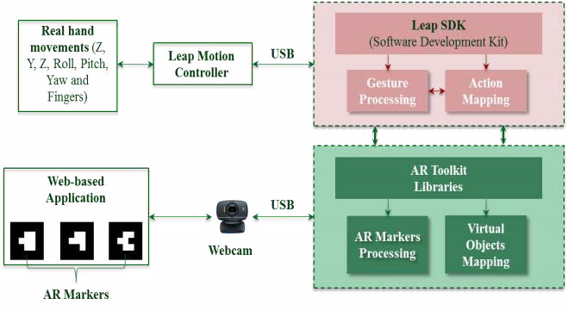
Fig.1. Extrusion technique Architecture

III. Proposed Research Methodology
The goal of our examination is to build up an Augmented Reality and hand gesture-based application for learning 3D geometry. This paper expects to show a unique approach for successful learning 3D geometry for preliminary school going children. At the end of the day, it endeavors to furnish understudies with a simple and an advantageous method to probably learn 3D geometry. As mentioned before, this paper does not propose a new method, instead it proposed a modified method called “Modified Extrusion Technique”.
The method essentially centered around two principle innovations Augmented Reality and hand gesture acknowledgment to develop a hands-on learning technique for the learner. With Augmented Reality, the learners can comprehend the fundamental ideas of 3D geometrical shapes, their connections and approaches to build the 3D shapes and the items in 3D space. Vitally, Augmented Reality can give a dynamic representation of 3D structures of geometrical shapes. This element causes the students to comprehend a complete foundation of 3D geometrical shapes and enhance the capacities of geometrical structures. In addition, the hand gesture-based connections outfit an instinctive and advantageous path for the understudies to specifically control and cooperate with geometrical shapes in 3D space. With the encounters of interfacing with the 3D shapes utilizing their own hand motions, the understudies can enhance their very own consciousness of the connections of the 3D shapes and effectively recollect or hold the learning about the 3D shapes.
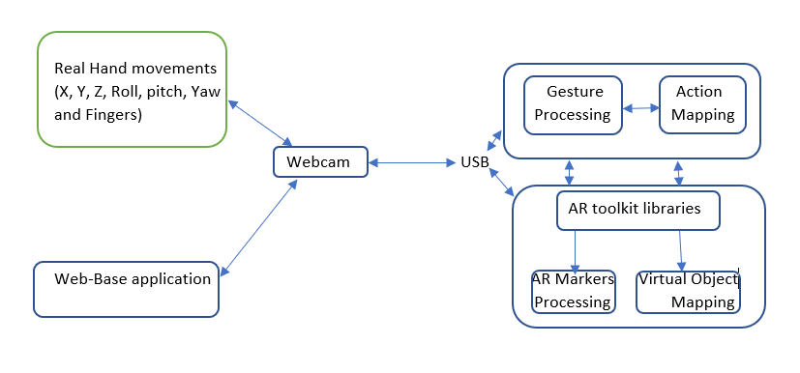
Fig.2. Modified Extrusion Technique Architecture
Architectural overview of the proposed system is shown in Fig. 2. The proposed system deals with dynamic hand gesture recognition, so this is a real time system. Various types of posture are enlisted for recognition, but firstly, only worked with the numbers of fingers to testify that whether the system can recognize hand or not. The system will visualize through a basic webcam to recognize the hand and hand gesture. Than it will bound the hand and extract the hand from other parts of body as the skin types are quite similar for hands and other parts of body. The student can visualize the geometry shape both in 2D and 3D with the assist of AR markers. Than the AR marker is obtained by the webcam. During the hand gesture recognition and the AR marker recognition, in both cases a webcam is used while the AR Toolkit libraries overlays and displays exactly the 3D virtual objects on those physical AR markers in the AR environment. Whenever the students or the teacher will try to interact the augmented shape, it will map the gesture and will produce pre-built geometrical shape in the augmented environment.
Recognition process starts with hand gesture recognition. Hand gesture is recognized through webcam. A series of hand-written code is used to recognize the hand gesture. The code is segmented is YCrCb skin detection, skin color detection and HSV skin color detection. The main reason of the code segmentation is to recognize the hand fully. Because, there could be any kind of disturbance like same color things, other parts of the body. So, despite all these problems the problems the code can segment the hand fully and can recognize the gesture.
The student can interact with virtually augmented 3D shape. For this they can use up to ten fingers. They can move, pinch, zoom in, zoom out, rotate the 3D shape. Some predefined gesture will be stored at the system. Interactors action will be observed through the webcam than it will mapped through action mapping function. Than the desired shape will be augmented or other tasks will be complete as the user want.
The next phase is recognition of marker. AR Toolkit libraries will be pre-installed on the system, so all the features and function of this library will be usable. The AR Controller function sets up some parameters about video orientation and barcode marker recognition (with markerUID and markerWidth). The arScene function includes all of parameters which are used to set up the scene for virtual object visualization, for example, renderer, camera, spotlight and objects. Moreover, the camera is configured using a physical webcam we use in our application. After calibrating the camera, the AR Toolkit calibration function generates a .dat file as the camera configuration which is located in the application directory and will be loaded for marker tracking and recognition.
After effectively stacking, the way toward illustration 2D and 3D virtual articles is rendered at whatever point the webcam catches the markers. With the AR Toolkit libraries, various markers can be perceived and pictured in the meantime. Every marker presents one sort of a geometrical shape. Fig. 3 demonstrates instances of the markers which are utilized in our application. Utilizing the AR Toolkit library, physical position, size and introduction of each obvious marker can be identified and perceived. The Virtual Object Mapping capacity of the AR Toolkit library assumes liability to show overlaid virtual articles onto these markers. Inside these center capacities, there are a few callbacks which are enlisted to supply an application explicit audience to conjured related capacities at whatever point clients control the virtual articles in customer side. In the customer side, understudies (who need to learn geometry) can imagine both 2D and 3D structures of geometrical shapes. They can see that the virtual articles are effectively put on the physical markers through the webcam. Every marker presents distinctive shapes. At that point, the understudies can control those virtual articles by hand signals and see the progressions of the items quickly.
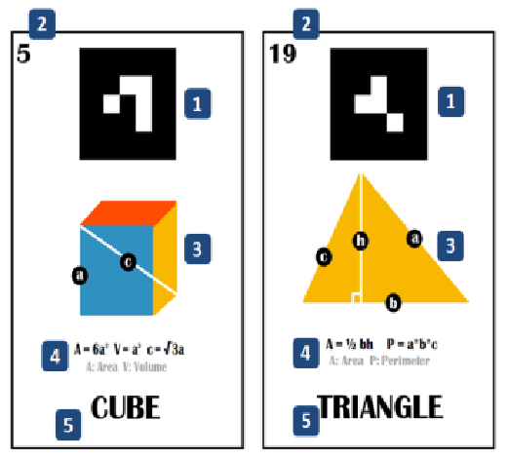
Fig. 3. Physical markers for both 2D and 3D shape [5]
The proposed system consists of various function to build up two dimensional and three-dimensional geometrical shape. The understudies can build 3D geometrical shapes dependent on a 2D shape or a lot of 2D shapes. Fundamentally, the understudies just need to give a few sorts of 2D shapes, and after that the framework will naturally produce comparing 3D shapes from them. Fig. 3 demonstrates a case of this capacity where a block, a circle and barrel are developed by changing 2D shapes, for example, a square, a circle and a chamber, separately.
Three noteworthy communication strategies for geometrical changes are determined: turn, scaling and panning, which can be performed by utilizing two hands and fingers of the students. The students can utilize two hands for scaling, the file and center fingers to turn the items and utilize the forefinger for panning or move the article around. It shows test associations utilizing hand motions which comprise of turn, moving, on a level plane and vertically scaling. The signals are indicated as straightforward as feasible for the understudies to recollect and perform effectively and helpfully. Point of view is also an important thing. The student will get a proper precession point to observe the geometrical shape with proper angle and perspective.

IV. Experimental results and Discussion
Our research is basically subdivided into three phases. They are recognition of hand gesture, recognition of AR marker and final step is to generate the geometrical shape with interaction process. As previously mentioned, we only worked with the numbers of fingers to testify that whether the system can recognize hand or not. So, we have conducted experiments on how accurately the program is recognizing enlisted postures. To further extend the results we have tried experiments with two types of program-
I. With Tracking: This program is able to track the hand from any position and extract it from other parts of body as the skin types are quite similar for hands and other parts of the body. It then puts AR markers around the hand. The program was developed using EmguCV. EmguCV is a cross-platform image-processing library. It is closely related to OpenCV because EmguCV is a .NET wrapper to OpenCV. We can say EmguCV is OpenCV in .NET. The approach shown is based on skin detection and convex hull and defects computation. So, for checking its accuracy we run this program in various backgrounds.
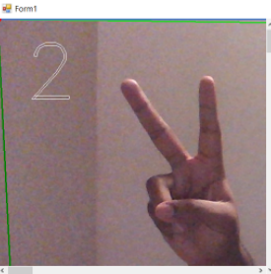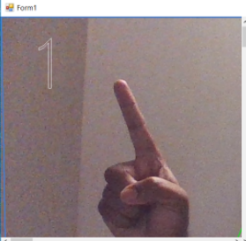
Fig. 4. Recognition in Simple Background
In Fig. 4 Regarding Simple (Non-Complex) background the program is able to track and recognize the gesture. As the color pallet of the background is different from skin color pallet it shows no problem in tracking the hand posture. So, in terms of simple/non-complex background this program holds potential.
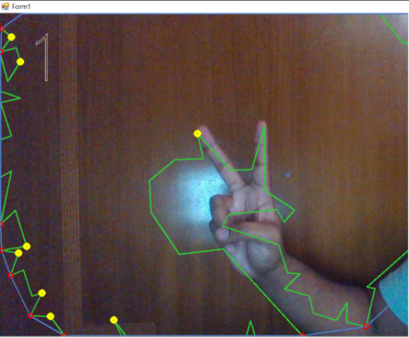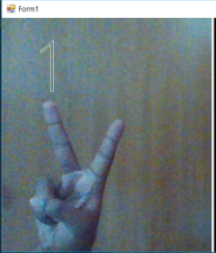
Fig. 5. Recognition in Complex Background
In Fig. 5 Regarding Complex background, it was observed that the program had great difficulties in tracking the hand. Rather most of the times it would track the background as it may have similar color pallet that of skin. Hence it rarely gave the correct response according to the posture.
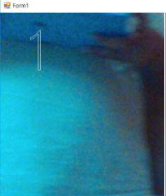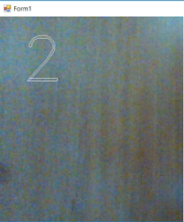
Fig. 6. Incorrect Recognition in Complex Background
In Fig. 6 Despite having no hand displayed on camera the program still responded in complex background because of matching color pallet with skin.
According to the discussion above it is apparent that it has a high accuracy rate in recognizing and tracking hand gestures when the background color pallet didn’t match with the skin color pallet. But it was mostly unable to recognize the hand when the background color pallet matched with the skin color pallet.
Table 2. Performance comparison (EmguCV)
Background Type | Accuracy | Error | Tracking Rate | System
Simple (Non-Complex) | 95% | 10% | 65% | Core i5 CPU with 2.70 GHz processor
Complex | 20% | 80% | 10% | Core i5 CPU with 2.70 GHz processor

II. Without Tracking: This program is able to track the hand from a specific position where only the hand will be shown. The program will recognize the hand from a specified area hence it doesn’t need to track. We use python as programming language, OpenCV library, Numpy array to develop this program. NumPy is the fundamental package for scientific computing with Python. So, for checking its accuracy we run this program in various backgrounds.

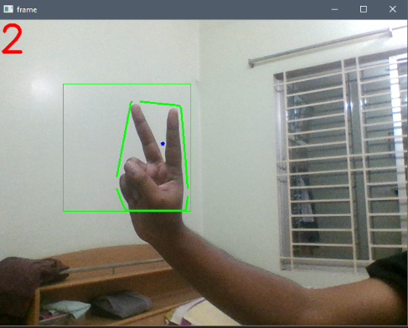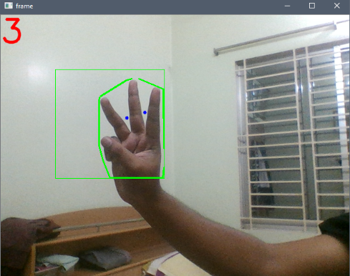
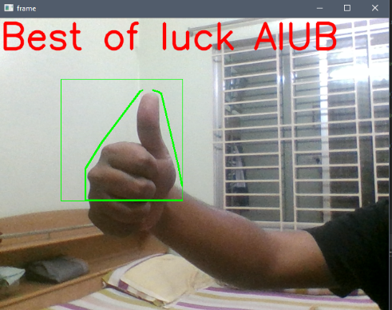
Fig. 7. Recognition in Simple Background
In Fig.7 Regarding Simple (Non-Complex) background the program is able to recognize the gesture when the hand is displayed in the specified area. As the color pallet of the background is different from skin color pallet it shows no problem in responding according to the hand postures. So, in terms of simple/non-complex background this program shows great results.
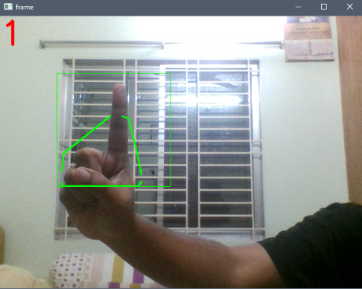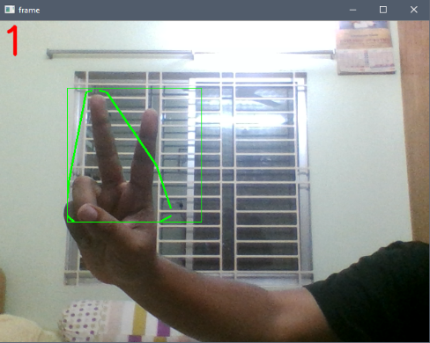
Fig. 8. Incorrect Recognition in Complex Background
In Fig. 8 Regarding Complex background, it was observed that the program had few difficulties in tracking the hand. Though with low accuracy rate the program was able to recognize the hand postures and responded accordingly.
The experiment shows promising result in both simple and complex background. Though it showed lower accuracy rate in complex backgrounds then the simple backgrounds it was still higher than the program with tracking based on complex back ground.
Table 3. Performance comparison (Python with NumPy)

Background Type | Accuracy | Error | Tracking Rate | System
Simple (Non-Complex) | 95% | 10% | None | Core i5 CPU with 2.2 GHz processor
Complex | 70% | 30% | None | Core i5 CPU with 2.2 GHz processor

V. Conclusion
There is some factor like lighting condition. Our findings find only one to deal with the light condition and the result was excellent in low light condition too. In addition, in case of dynamic hand gesture recognition the data set become larger and larger. Than it needs a huge database. Complexity of the method and computational time both increase in that case. As we concern about education purpose, so there must be a way of interaction between the teacher and the learner on augmented object. But most of the published work is not interactive. So, what we need is really challenging in this stage of AR research. We need a fully dynamic, collaborative and interactive hand gesture recognition system for the education environment within low complexity and independent.
We have discussed two types of program to follow up the “Modified Extrusion Technique” in order to compare their performances with each other as well as come to a decision on which to use in the established method. Although the above-mentioned programs are not yet completed in order to run with the system, they have shown progress in achieving our goal. Our Future work will include in implementing one of these programs so that their output can be used as inputs for other tools (in this case: Construct3D) and control them. That way using the program we can control the geometrical 3D shapes with our hands. Another positive point is that it will not be so costly. The whole completed system will be a significant progress towards the field of Augmented Reality

VII. References
[1] Kaufrmann, Hames and Schmalstieg, Dieter, “Mathematics and Geometry Education with Collaboration Augmented Reality”, Computers & Graphics, vol. 27, issue 3, June 2003, pages 339-345. Accessed at: https://doi.org/10.1016/S0097-8493 (03)00028-1.
[2] M.I.N.P. Munasinghev, “Dynamic hand gesture recognition using computer vision and neural networks”, 2018 3rd International Conference for Convergence in Technology (I2CT). doi: 10.1109/I2CT.2018.8529335
[3] Alani et al. (2018), “Trajectory based hand gesture recognition using Kinect via deterministic learning”, 2018 37th Chinese Control Conference (CCC). doi:10.23919/ChiCC.2018.8482621
[4] Oka et al. (2002), “Real-time fingertips tracking and gesture recognition”,IEEE Computer Graphics and Applications (Volume: 22, Issue: 6 , Nov/Dec 2002 ) .doi: 10.1109/MCG.2002.1046630
[5]. Hong-Quan Le, Jee-In Kim,“An Augmented Reality Application with Hand Gestures for Learning 3D Geometry”. 2017 IEEE International Conference on Big Data and Smart Computing (BigComp). doi:10.1109/BIGCOMP.2017.7881712
[6]. Meiping Tao, Li Ma, “A Hand Gesture Recognition Model Based on Semi-supervised Learning”, 2015 7th International Conference on Intelligent Human-Machine Systems and Cybernetics, doi:10.1109/IHMSC.2015.230
[7] Fan Zhang, Yue Liu, ChunyuZou, Yongtian Wang, “Hand gesture recognition based on HOG-LBP feature”, 2018 IEEE International Instrumentation and Measurement Technology Conference (I2MTC). doi: 10.1109/I2MTC.2018.8409816
[8]. Ali A. Alani, Georgina Cosma, AboozarTaherkhani ,T.M McGinnity,“Hand Gesture Recognition Using an Adapted Convolutional Neural Network with Data Augmentation”.2018 4th International Conference on Information Management (ICIM). doi:10.1109/INFOMAN.2018.8392660
[9]. Hannes Kaufmann, “The potential of augmented reality in dynamic geometry education”, Accessed at: https://www.researchgate.net/publication/228350641_The_potential_of_augmented_reality_in_dynamic_geometry_education.

Author’s Profile:

A.F.M. Saifuddin Saifreceived Ph.D. from Faculty of Information Science and Technology, University Kebangsaan Malaysia (UKM) in 2016. He received M.Sc. in Computer System Engineering (Software System) from University of East London, UK, and B.Sc. (Eng.) degree in Computer Science and Engineering from Shahjalal University of Science and Technology, Bangladesh in 2012 and 2008, respectively. Most of his contributions in Computer Vision and Artificial Intelligence Research field were published in ISI Q1 journals. He has published many papers in ISI indexed Journals; Scopus indexed Journals, Book Chapters, Conferences, and Proceedings. He served as Technical Committee Members, Reviewers, Guest Speakers, Session Chairs in many Conferences and Workshops. Currently, he is an Assistant Professor at Faculty of Science and Information Technology, American International University Bangladesh (AIUB). Before joining the university, he did Post Doctorate at Faculty of Information Science and Technology, University Kebangsaan Malaysia. He spent more than 6 years in IT industry such as Advanced Software Development, Web eMaze etc. as IT researcher. His research interests include Image Processing, Computer Vision, Artificial Intelligence, Augmented Reality, 3D Reconstruction, and Medical Image Processing.

Md. Mashiul Azam Chowdhury Efti is an undergraduate student of Computer Science and Engineering under the Faculty of Science and Information Technology of American International University Bangladesh. His research interests and passion are mostly based on Computer Vision and Pattern Recognition, Artificial Neural Network, Augmented Reality, Virtual Reality, Machine Learning, Object Tracking and Detection, Internet of Things.


Md. Rakibul Hossain is an undergraduate student of Computer Science and Engineering under the Faculty of Science and Information Technology of American International University Bangladesh. His research interests includemostly based on Computer Vision and Pattern Recognition, Image processing, Artificial Neural Network, Color Segmentation, Machine Learning, Object Tracking and Detection.


Md. Reza Ul Karim is an undergraduate student of Computer Science and Engineering under the Faculty of Science and Information Technology of American International University Bangladesh. His research interests and passion are mostly based on Computer Vision and Pattern Recognition, Image processing, Artificial Neural Network, Color Segmentation, Machine Learning, Object Tracking and Detection, Evolutionary Computation.


Rajesh Saha is an undergraduate student of Computer Science and Engineering from Faculty of Science and Information Technology of American International University Bangladesh. His interests and passion for research are mainly based on Computer Vision and Pattern Recognition, Image processing, Neural Network, Machine Learning, Object Tracking and Detection.

